1. BS Communication: BS protocol is for communication between WAN Server and the attendance terminals to obtain attendance data and manage user data. The protocol is Websocket, whose default is encrypted. But you can use it that isn’t encrypted. The main logic is the Server monitors a port. Set the Server IP and Port on the device, then connect the device to the Server.

Websocket: API in XML format

Time Attendance Terminal

Server

More details about API in XML format, please refer to the file “websocket-API-2019.11.14”

1. We have a local test demo for you to test the API. The demo runs on the local PC. Create a websocket Server locally, and set the IP (the same as the PC) and the port, then you can test the device locally.
2. Description of Demo

Demo includes **source code** and **compiled executable application**. The source code is based on C#. The compiled executable application file is as below:

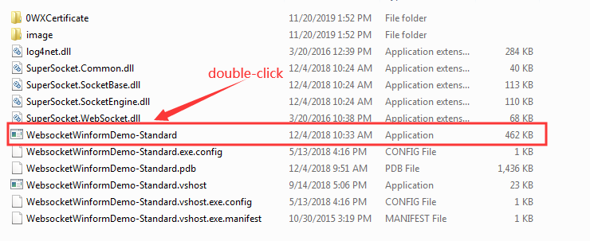

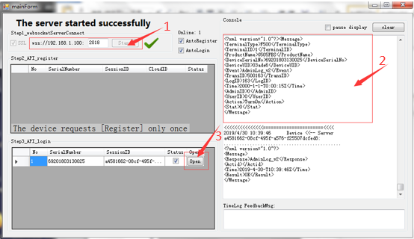

It’s the port No. of the PC’s IP, which is the Server Address you need to set on the device. (Menu>>Network/ Communication)

Noted: wss:// is ssl encrypted websocket protocol. The demo applies ssl, then you should input the URL that begins with wss:// on the device. If the server doesn’t apply ssl, you can input the URL that begins with ws://.

192.168.1.100 is the IP of the PC, which is obtained automatically on the demo. If there are multiple network cards on the PC, the IP might be incorrect. You should input the actual IP on the device. Regarding the port No., don’t occupy the system’s port.

It’s XML original data, which shows the specific communication data at that time.

Noted: If there is no device connect successfully, you should check whether the Server IP on the device is the same as it on the PC and whether the format is correct first. Secondly, Ping the IP on the device, if it doesn’t work, please check the network; if IP on the device and the IP of the PC are in different network segment, please make the IP on the device as same as the PC’s. Last, close the firewall and try.

It’s the button for common operation. Click “Open” and you can operate.

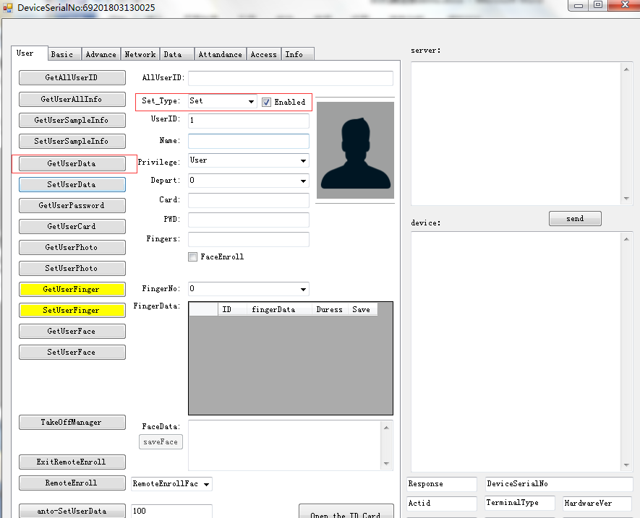

Communication Settings on the device

Model A-L315/325/355/365: Menu>>Network>>Websocket Server URL

**Noted: The demo should be run on Windows 8 or above.**